

Invertebrate Anatomy

**BSC 2011 Laboratory**

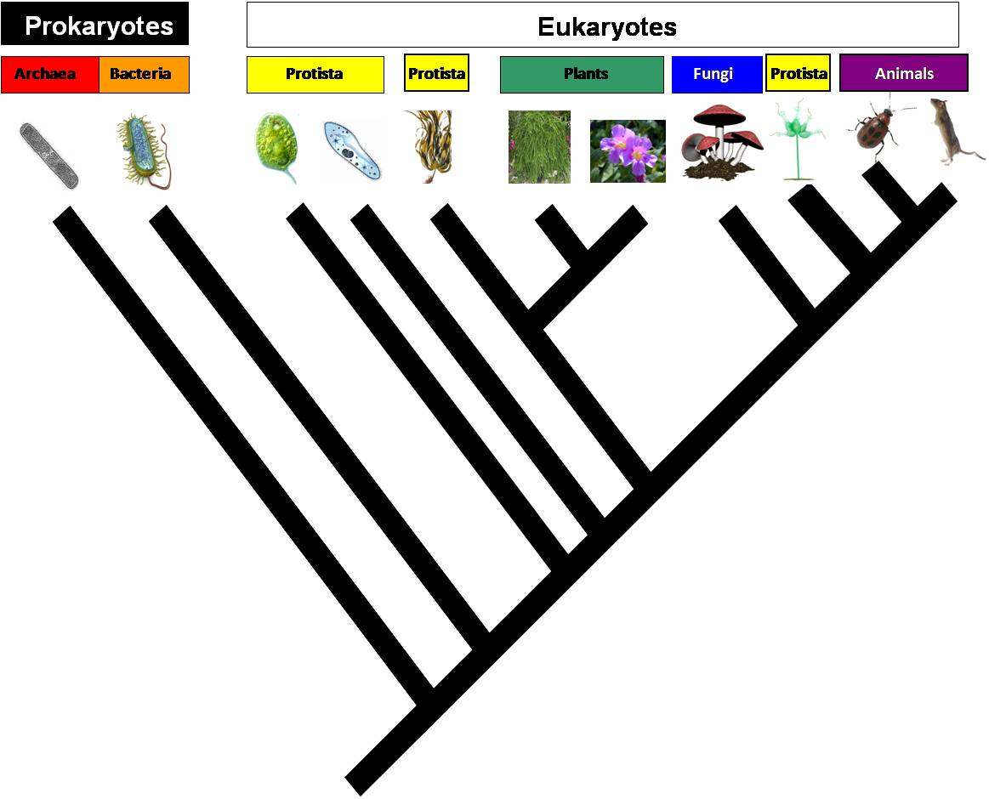

Two phyla (Mollusca and Arthropoda) encompass much of the morphological, ecological, and species diversity within the clade Bilateria (bilateral animals). Both phyla are ***protostome*** groups (mouth develops from the blastopore), but they have very different ***musculoskeletal*** and ***circulatory*** systems. Also, the Mollusca belong to the Lophotrochozoa, while the Arthropoda belong to the Ecdysozoa.

Mollusca comes from the Latin *molluscus* meaning “soft”, which indicates that these organisms are soft-bodied creatures. Mollusks have a body plan made from 3 main body parts: a muscular foot for locomotion, a visceral mass containing most of the internal organs, and a mantle that covers the visceral mass and internal organs but is not enclosed within the visceral mass. Most mantles also typically secrete a shell. Today we will examine the squid, an organism from the Class Cephalopoda. The muscular foot has been modified in cephalopods into the tentacles, parts of the head, and a muscular excurrent siphon, which they use for locomotion. A mantle covers the internal organs of cephalopods, but the shell has been reduced and internalized in the squid.

Arthropoda comes from the Greek *arthropod* meaning “jointed feet”, which refers to the segmentation and jointed appendages of this group. Another prominent feature of arthropods is their hard exoskeleton. Today’s lab will examine the crayfish, an organism from the Class Crustacea. Crustaceans are known for their serially homologous, biramous (branched) appendages that have been extensively modified to perform specialized tasks. Crustaceans also are the only arthropods with 2 pairs of antennae.

**Objectives**

* Identify major external and internal anatomical features of a cephalopod and a crustacean
* Understand the function of major tissues, organs, and systems
* Understand the concepts of homologous structures and serial homology

**Materials**

* Dissecting tools

***Specimens*:**

Squid

Crayfish

**Squid** (*Loligo sp.*)

External Anatomy

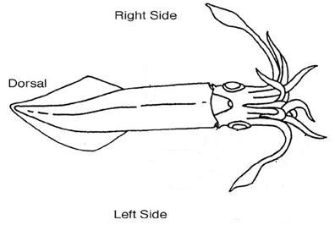

Place the squid dorsal side up (the gladius should be on the bottom) in the dissecting pan. Identify each structure of the squid’s external anatomy: **arms**, two longer **feeding tentacles**, **head**, **eyes**, **fins**, **mantle**, **excurrent siphon** (funnel), **tail**, **suckers**, **beak**, and **mouth**. How do the placement of the arm and tentacle suckers differ? Why does this difference occur?

How does the squid use its funnel, mantle and fins for locomotion?

Match each structure of the squid’s external anatomy with the appropriate letter.

Eye ____

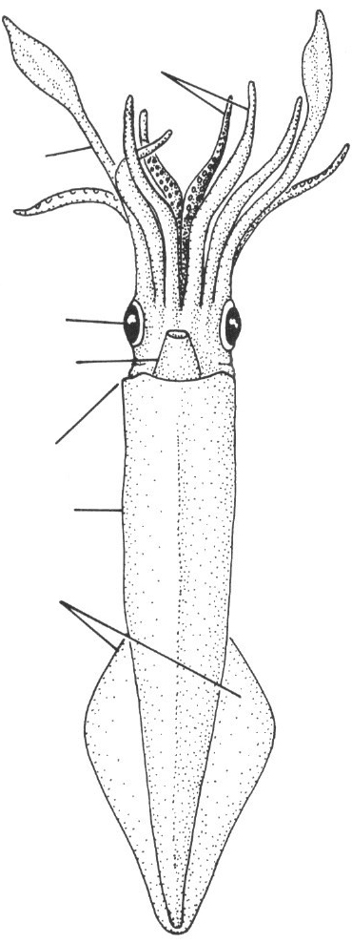

**A**

**B**

**C**

**E**

**F**

**G**

**D**

Arm Tentacles ____

Feeding Tentacles ____

Excurrent siphon (funnel) ____

Mantle ____

Tail ____

Fins ____

Internal Anatomy

Observe the mouth of the squid by opening and closing the beak. With tweezers, locate the small chitinous ***radula*** between the beaks and remove it. What is the radula’s function?

Next, open the mantle. Using forceps and scissors, gently cut along the ventral midline from the mantle opening to the tail. Take care to avoid damaging the soft internal organs. Locate the long, feather-shaped organs within the mantle cavity; these are the **gills**. At the base of each gill is a small, white, circular structure, the **gill (branchial) hear**t. What is the function of the gill hearts?

Squid also have a separate **systemic heart**, which lies directly between the gills. What is the function of the systemic heart? Why do squid have separate hearts for the gills alone?

The gladius and cranium comprise the squid’s skeleton. The ***gladius*** is the long, translucent, plastic-like structure that runs the length of the body and supports the mantle and internal organs. Remove the gladius from inside the open mantle (you may need to cut away connective tissues that hold it in place).

Next find the **ink sac** – the long, dark tube that opens near the funnel. Running parallel to the ink sac is the **intestine** which ends at the **anus**. What is the function of the ink sac? Why does it open near the funnel? Why does the anus also occur near the funnel?

***Writing with the ink sac***

*Caution: Squid ink will stain your clothing.* Remove the ink sac, place it in a cup and release the ink by making a small incision at one end of the sac. Use forceps to press it against the bottom of the cup. If the ink is dry / pasty, add one drop of water at a time to create fluid ink. Dip one end of the gladius into the ink until the tip is full and use it to write your name below. Squid ink was used to write in ancient times, and still is used today in some cultures. Unfortunately, it tends to fade over time – except from your clothes.

Write name here:

Locate the stomach and caecum. The **caecum** is the large white mass located at the posterior end of the mantle. The **stomach** lies anterior to the caecum and contains visible folds; it looks like a piece of chewing gum. Connected to the stomach is the large digestive gland, also known as the liver. Open the stomach (coiled sac) and examine its contents. Can you determine what the squid ate for its last meal? _____________________________________________________________

The small intestine is connected to the stomach at its posterior end. The coils of the small intestine are smaller and more tightly coiled than those of the large intestine. The small intestine leads to the large intestine. Find both the **small and large intestines**.

Three main structures lead from the mantle to the head. The esophagus lies between the two large retractor muscles that pull the head into the mantle, forcing water out of the funnel and allowing the squid to propel itself through the water.

Last, locate the gonads. Female squid have eggs in a jelly-like conical sac at the posterior end of the mantle, just below the **nidamental gland**. The large, firm, white nidamental gland lies on top of the other internal organs. Nidamental glands secrete the gelatinous matrix that envelops the eggs. Male squid lack nidamental glands. Instead, males have a white, fluid-filled genital sac in the posterior end of the mantle. Sperm produced there are transported in thin tubes to an elongated, opaque sac (penis) running parallel to the ink sac and intestine. Is your squid male or female? ______________________________________________________________________

Within the squid’s internal anatomy, identify the **bolded structures** listed below.

**Ink Sac**

**Gills**

**Intestine**

**Gill heart**

**Stomach**

**Systemic heart**

**Testes**

**Anus**

**Caecum**

**Penis**

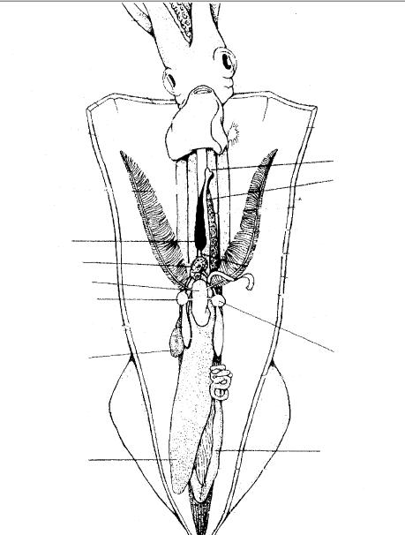

Male Squid

**Nidamental gland**

**Oviductal opening**

**Oviduct**

**Oviductal gland**

**Ovary with eggs**

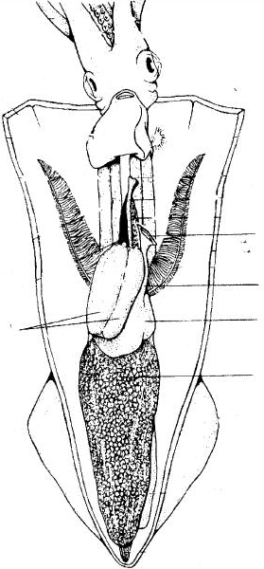

Female squid

**Crayfish** (*Decapoda*)

External Anatomy

Place the crayfish with its dorsal side up in a dissecting pan. A chitinous carapace covers the crayfish’s body and forms an exoskeleton. Locate the two body regions: **cephalothorax** and **abdomen**. What is the main structural difference between the cephalothorax and abdomen?

Crayfish appendages illustrate an important biological concept; serial homology. Structures within an organism exhibit ***serial homology*** if the structures are repeated and have similar developmental origins. In the simplest condition, each segment of a crustacean has one pair of appendages. In decapod crustaceans – including crayfish – a series of nineteen initially similar appendages have been modified to perform different tasks.

Turn the crayfish so it is lying dorsal side down in the dissecting pan. Find each appendage listed in the **table at the end of this chapter** and remove these appendages from one side of the crayfish. Tape each appendage to the table at the end of the chapter and briefly describe the function in the space provided. The two illustrations below and the following written instructions will assist you in identification.

Locate the rostrum, which is the pointed, anterior most extension of the carapace between the two eyes. Two types of antennae are located next to the rostrum: the **antennules** (short, paired antennae) and **antennae** (long, single antennae). Next, locate the largest, obvious pair of appendages, the **chelipeds** (claws). The appendage directly anterior (in front) to the cheliped is the 3rd maxilliped. Directly below the 3rd maxilliped are the 2nd and 1st maxillipeds. Remove the maxillipeds and locate the two pairs of maxillae. The 2nd maxilla contains a ***gill bailer***, an important respiratory structure. Next, locate the mandible, the chitinous structure at the opening of the mouth.

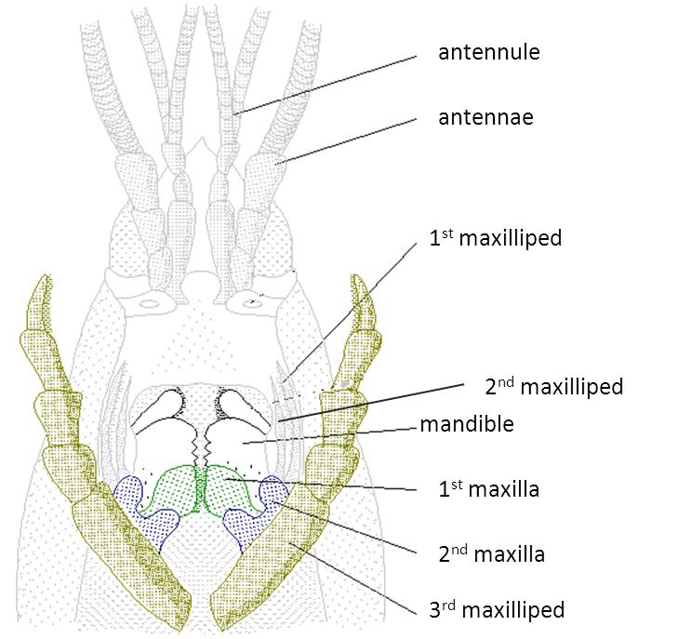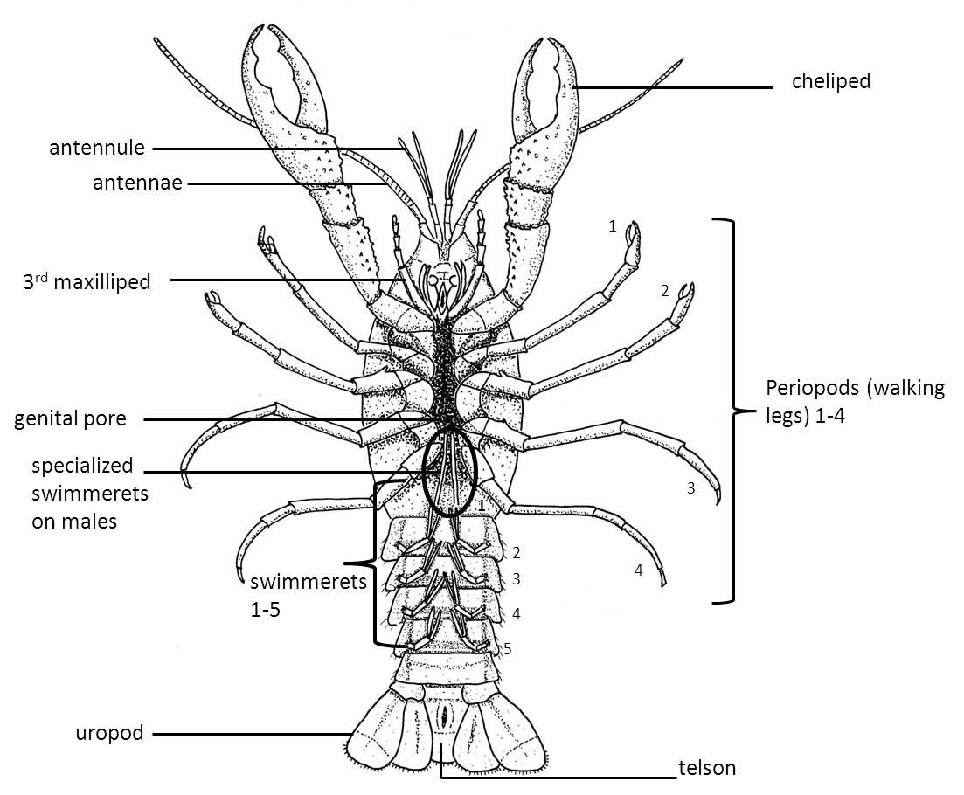

Relocate the chelipeds. Directly posterior to the chelipeds are four pairs of **periopods** (walking legs), one pair on each thoracic segment. Attached to the segmented abdomen are five pairs of swimmerets. The last abdominal segment has a triangular-shaped telson flanked by a pair of **uropods**.

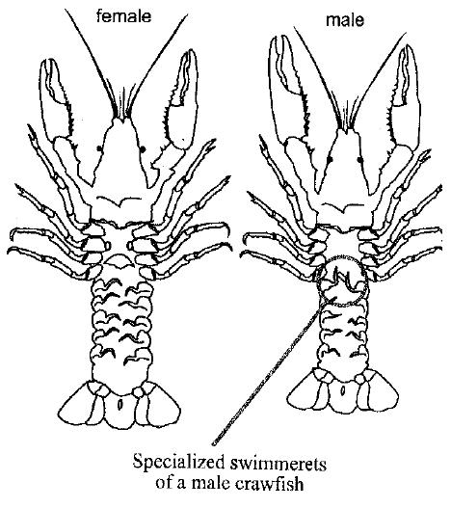

Locate the basal segment of the third pair of walking legs. If a crescent-shaped genital pore occurs between these legs, your specimen is a female. If the crayfish lacks a genital pore, your specimen is a male. The abdomen has six distinct segments. A pair of **swimmerets** occurs on each of the first five segments. The swimmerets of female crayfish are longer than those of males. Why?

In mature male crayfish, the first pair of swimmerets is enlarged and chitinous; they are used as copulatory organs. In fact, most keys for identifying crayfish are based on these ***copulatory swimmerets***. Is your specimen a male or female? ____________

Internal Anatomy

Using scissors, carefully cut down the midline beginning at the posterior end of the dorsal side of the cephalothorax until you reach the “Y” at the posterior end of the head. Cut along the “Y” until you reach the end of the carapace, and carefully lift the carapace from the underlying structures. What are the underlying, feathery structures that occupy this region? ___________

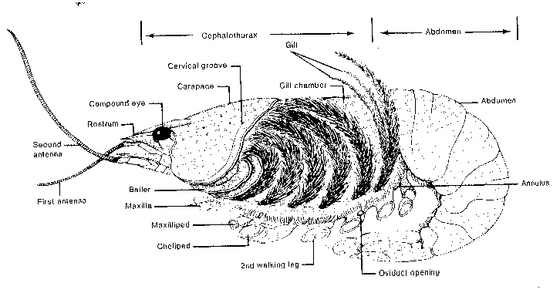

Like most gills the gill structure of crustaceans provides a very large surface area. Why is this important?

______________________________________________________________________________

______________________________________________________________________________

How do crayfish maintain a constant flow of aerated water across their gills? Which appendage do they use?

The dorsal tubular heart and several arteries lie just below the carapace. Hopefully you did not damage these organs of the circulatory system when you removed the shell. Crayfish have an **open circulatory system**: blood flows from arteries into sinuses within tissues. Deoxygenated blood flows over the gills before returning to the heart. Blood also carries cellular wastes to the disk-like green glands. The ***green glands*** are located posterior to the antennae and aid in removing nitrogenous wastes from the body, while retaining important nutrients (e.g., salt).

What organ in the human body performs the same excretory function as the green glands?

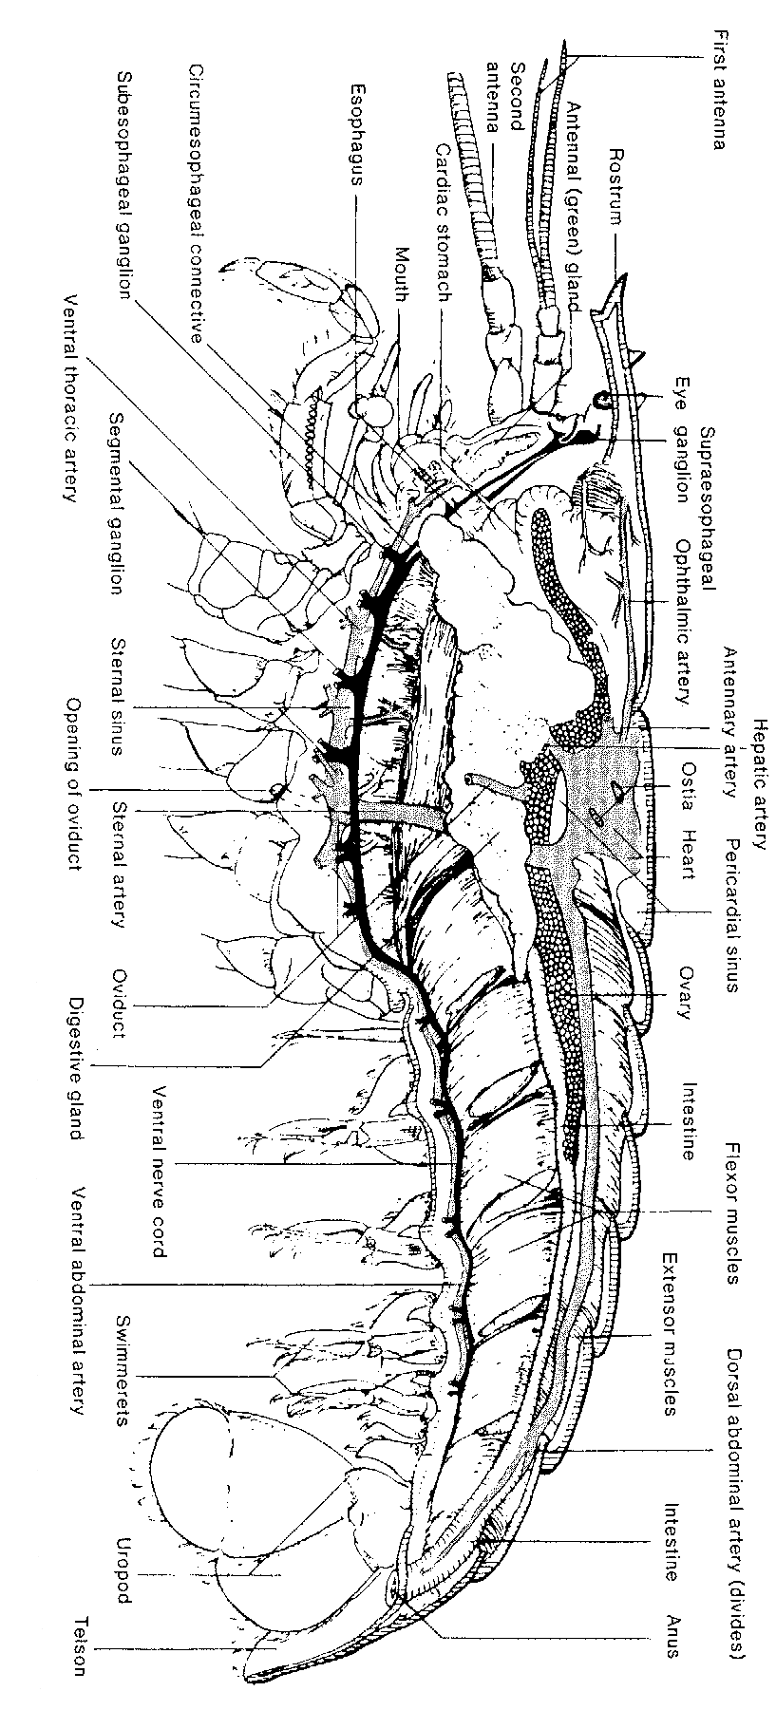

**Critical Thinking**

1. Human hearts are red or purple due to the presence of the respiratory pigment hemoglobin. Squid gill hearts are white due to the respiratory pigment Hemocyanin. How does hemocyanin differ from hemoglobin, and how is this beneficial to squid and other mollusks?

2. Which of these organisms is least closely related to the crayfish? Why?

A. Crabs B. Lobters C. Scorpion D. Barnacles



|  |  |  |
| --- | --- | --- |
| **Name** | **Structure** | **Function** |
| **Antenna** |  | Sensory organ |
| **Antennule** |  | Sensory organ |
| **1st maxilliped** |  | Holding prey; bears a gill |
| **2nd maxilliped** |  | Holding prey; bears a gill |
| **3rd maxilliped** |  | Holding prey; bears a gill |
| **1st maxilla** |  | Food handling |
| **2nd maxilla** |  | Food handling and gill bailer (respiration); bears a gill |
| **Mandible** |  | Chewing and grinding prey |
| **Cheliped** |  | Catching and grasping prey; defense |
| **Periopod** |  | Walking |
| **Swimmeret** |  | Swimming; Modified in sexes for carrying eggs (female) and sperm transfer (male) |
| **Telson** |  | Swimming and escape |
| **Uropod** |  | Swimming and escape |

|  |  |  |
| --- | --- | --- |
| **Name** | **Structure** | **Function** |
| **Antenna** |  | Sensory organ |
| **Antennule** |  | Sensory organ |
| **1st maxilliped** |  | Holding prey; bears a gill |
| **2nd maxilliped** |  | Holding prey; bears a gill |
| **3rd maxilliped** |  | Holding prey; bears a gill |
| **1st maxilla** |  | Food handling |
| **2nd maxilla** |  | Food handling and gill bailer (respiration); bears a gill |
| **Mandible** |  | Chewing and grinding prey |
| **Cheliped** |  | Catching and grasping prey; defense |
| **Periopod** |  | Walking |
| **Swimmeret** |  | Swimming; Modified in sexes for carrying eggs (female) and sperm transfer (male) |
| **Telson** |  | Swimming and escape |
| **Uropod** |  | Swimming and escape |